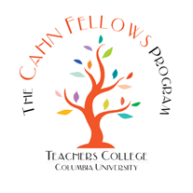
The effects of leadership on student learning are well documented in the research. According to the Wallace Foundation, “It turns out that leadership not only matters: it is second only to teaching among school-related factors in its impact on student learning.” (Leithwood, Louis, Anderson, & Wahlstrom, 2004, p. 3)

Recognizing an urgency to provide leadership development for principals, the Cahn Fellows Program for Distinguished Principals was created in New York City in 2003 with the belief that if we engage principals in a collaborative network of peers, increase their ability to build capacity, improve teacher effectiveness and school culture, then we will have an impact on retention of the strongest principals in the educational system, address the ongoing need to build capacity, and ultimately elevate student learning and achievement.

The research recently conducted for the development of our five year strategic plan revealed that principals who have completed our year-long course of study have benefitted from our high quality curricula, which is among the strongest in the field of comparable peer programs.

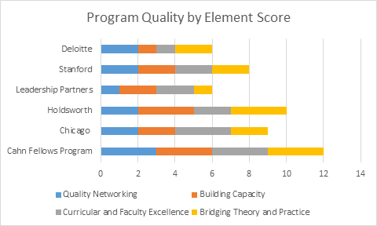

We provide advanced professional development in leadership growth by offering high performing public school principals from large urban school districts the opportunity to participate in a rich learning experience provided by Teachers College (TC) faculty and distinguished guest faculty emphasizing intellectual exchange, reflective practice, and measurable results, all of which center on the final project, the authentic, school based problem of practice component of our curriculum and a truly unique aspect of the program.

Our Client Satisfaction Survey results revealed that every measure of success increased after participation in the Cahn Fellows Program with 65% of participants stating that the Cahn Fellows Program improved their leadership skills.
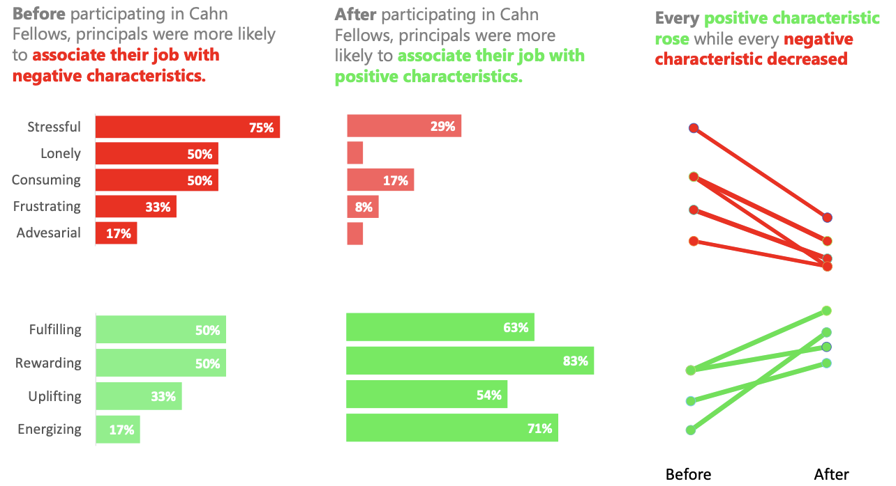
We are embarking on an ambitious strategic plan that will offer our program to school districts in the West Coast, build a curriculum for mid-level Principals and increase the role of our city Advisory Councils aligned with alumni engagement and professional development.

